## Titleblocks and Sheets ☑

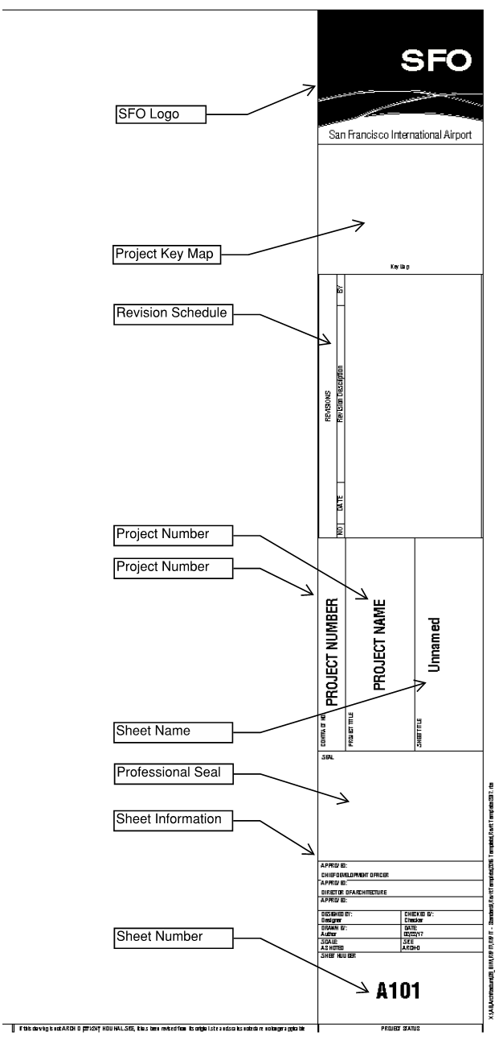The SFO title block is a parametric family that displays the logo, project information, issue dates, revision information and professional seals on each sheet. The Project Name, Number, Address parameters can all be accessed under the “Manage” tab, through “Project Information” and should be filled out for every project. The title block also has on/off parameters for professional seals, a grid and horizontal and vertical note blocks to help standardize sheet layouts.

Figure 5.1‑1 SFO Title Block